Fig-1 Helical gear cutting on horizontal universal milling machine

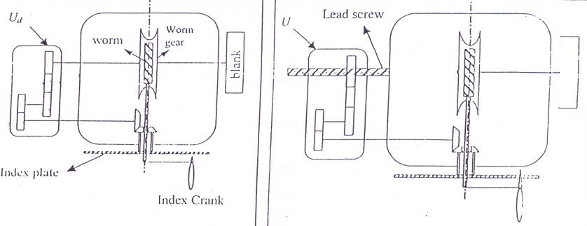

Fig-2 Dividing head set-up for Fig-3 Dividing head set-up for helical milling
differential indexing

Question:

- What are the advantage of helical gear over a straight spur gear ?
- What are the source of error in the above method of cutting a helical gear ?
- What is a herringbone gear ?
- Justify the selection of the cutter as explained here.

Department of Mechanical Engineering
Indian Institute of Technology Kharagpur
Machine Tools and Machining Laboratory
(Laboratory assignments)

Milling of Helical Gear

Objective : To machine a 12 D.P., 73 teeth, right hand helical gear with 15⁰ helix angle on a horizontal column and knee type universal milling machine with a rotary disc-type form gear cutter.

Apparatus : Horizontal column and knee type universal Milling machine, 12 D.P. No. 2 Cutter, Gear Tools, Vernier caliper, Dial indicator, Cast iron gear blank and mandrel, Change gears, Indexing head.

Theory : Though gears are presently manufactured in quantity in gear bobbing, shaping and broaching machines, once in a while, a milling machine might have to be set up for gear cutting for an odd job like a replacement gear. For example, single piece gear requirements are quite common in toolrooms and maintenance shops. For cutting a helical gear, two things are important. The relative motion of the job with respect to the cutter must be along a helical path defined by its pitch diameter and -helix angle. Secondly, the orientation of the cutter should be such that the vertical plane containing it is aligned with this relative motion. To satisfy the first requirement, the gear blank is mounted on the chuck of the dividing head and the lead screw for longitudinal motion is connected to drive the dividing head ( through the index plate & crank ) through a set of change gears. To orient the cutter in the direction of the relative motion (which is along the direction of the gear teeth helices), the table is rotated through the helix angle in the required direction about its vertical axis. The above set-up would permit the cutting of a helical gear quite satisfactorily. However, with milling comes the question of indexing. In this exercise, a number of teeth has been chosen for the gear which cannot be obtained by simple indexing. In this case, differential indexing is resorted to. The basic idea of differential indexing is feedback. When a particular output (in this case, the dividing head chuck rotation) is not directly available, the output is fed back through a transfer function (change gears) for a corrective rotation at the input side (index plate rotation) to obtain the desired results.

The essential mathematical relations are like :
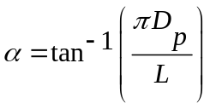 where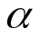is the helix angle,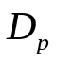,the pitch diameter in mm and L the lead of the helix in mm.
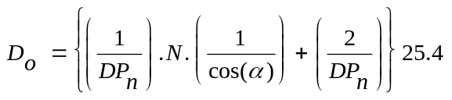 where 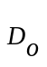= outer dia of gear = blank dia in mm where 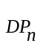= Normal Diametral Pitch, N = number of teeth
Here, the problem is to determine the ratio of the gear box U(Fig 1 & 3) (present in between the lead screw and the dividing head) which would enable the cutting of the required helical teeth. Further, it should also be possible to perform differential indexing of the gear blank in the same setting so that the required number of teeth would be cut. U can be calculated from the consideration that while the table moves by L, the dividing head should rotate once. For differential indexing (Fig 2),

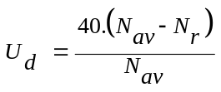 where 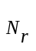= required number of teeth,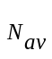 = nearest available hole circle on index plate, Number of teeth to be considered for selection of cutter =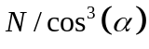
Available change gears -- 24 X 2, 28, 32, 40, 48, 56, 64, 72, 80, 86, 96, 100

